Volumes From Spot Heights - Grid Levelling
Previously levels have been located on cross sections and along a centre line. A convenient variation of this is the method of grid levelling. It is used extensively for site investigations, for irrigation, for drawing contours, to minimise computations of position and for the easy calculation of volumes.
Rectangular Base Method
The figure below shows a typical survey of a site using grid levels. At each and every intersection of the grid (which unfortunately must be established in the field) a level is obtained. The general problem is to calculate the volume of material above or below a certain reduced level (RL). It should be pointed out that this method will only calculate the net volume and not the gross volume (made up of cut and fill volumes). Generally this is a disadvantage as the RL to which the calculations are referred MUST NOT intersect the surface defined by the grid of levels. This problem is investigated later in this section to locate the line of 'zero cut and fill'.
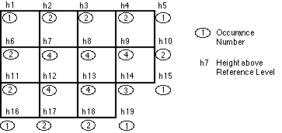
In the figure above the grid interval is s in both directions, therefore the area of a grid element is s². The reference RL is defined as RL₀ and the problem is to calculate the volume of material between this horizontal plane and the surface defined by the grid levels. The height difference at each grid point is given by;
h_{i} = RL_{i} - RL₀
Now assume that the solid figure of each grid element is a truncated prism of which the right area is s² and the height of the prism through the centre of gravity is approximated to the mean of the four corner heights. Therefore for the first element the volume is, |  | 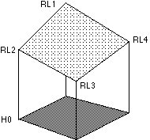
V₁ = s² | (h₁ + h₂ + h₆ + h₇)
V₁ = s² | 4
For the second and third elements the volumes are,
V₁ = s² | (h₂ + h₃ + h₇ + h₈)
V₁ = s² | 4
V₁ = s² | (h₃ + h₄ + h₈ + h₉)
V₁ = s² | 4
The total volume of the area covered by the entire grid of levels is,
V = [V₁ + V₂ + V₃ + ............. + V_{n}]
and therefore the volume in general terms may be expressed as,
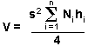
s² is the area of the grid cell
N_{i} is the Occurrence number,
h_{i} is the height difference at each point,.
This method is based on the assumption that the level for each grid element is the mean of the four corner levels. This is, in the majority of cases, an invalid assumption. It will not lead to significant errors if the terrain is reasonably flat or if the grid spacing (s) is small with respect to the surface roughness. The problem can be avoided (but not totally eliminated) if each square element is considered to be a prism on a triangular base.

Triangular Base Method
Triangular elements can better define the surface because any three levels will define a plane where as four levels (in the general case) will only define a warped non planar surface.
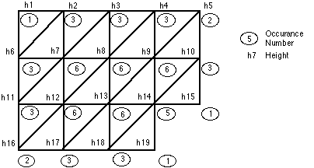
In this case the area will become (s²/2). Then the total volume as made up of a series of prisms on triangular bases and be developed by,
V1 = (h₁ + h₂ + h₆) s²/6
For the second and third elements the volumes are,
V2 = (h₂ + h₆ + h₇) s²/6
V3 = (h₂ + h₃ + h₇) s²/6
The total volume of the area covered by the entire grid of levels is,
V = [V₁ + V₂ + V₃ + ............. + V_{n}]
and therefore the volume in general terms may be expressed as,
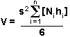
where N_{i} is the occurrence number,
h_{i} is the height difference at each point,
s² the area of the square grid element,
Of course the occurrence numbers will change from the previous case of the rectangular prisms .
Volumes from spot heights is convenient but is generally restricted to small areas since the setting out and levelling of a large grid can be extremely tedious and time consuming. The use of triangles rather than rectangles will usually increase the accuracy slightly, though it will tend to increase the amount of arithmetic involved.
Balance of Cut and Fill
As introduced before the above grid levelling formulae will only give the net volume. The datum plane should not ordinarily intersect the terrain. This, in one special case, can be turned into an advantage.
How can an area be levelled so that the amount of cut volume is equal to the amount of fill volume?
What is the reduced level of the resulting level plane?
In this case the net volume will be zero; Volume of cut = Volume of fill.
The problem then becomes determining what is the R.L. (Reduced Level) of the line of zero cut/fill. In this particular case the line will be a contour line (i.e. the intersection of a horizontal plane with the terrain) but in general the solution is far more complex.
If the area is grid levelled then let the required Reduced Level be RL_{x}; then for each point
h_{i} = RL_{i} - RL_{x}
This amount will be positive in areas of cut and negative in areas of fill and zero on the balance line .
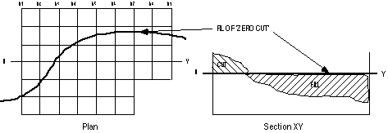
As before the volume of material above RL_{x} can be given by;
For the volume of cut to equal the volume of fill,
ΣN_{i}h_{i}.s²/4 = 0
that is N_{i}(RL_{i} - RL_{x}) = 0, but N_{i} = 4G where G is the number of grid elements or sections.
ΣN_{i}RL_{i} - ΣN_{i}RL_{x} = 0 | and ΣN_{i}RL_{i} = 4GRL_{x}
∴ ΣN_{i}RL_{i} - 4GRL_{x} = 0
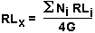
As N_{i} and RL_{i} are known for every point and 4G is known for the entire grid area the RL of the cut and fill line may be determined. This solution has been simplified by disregarding two features. Firstly, it is stated that the area is to be levelled; this is a common occurrence for tennis courts and house and building sites but ignores the more complex problem of an inclined intersecting plane or even more complex, the intersection of several planes with the terrain. Secondly, the solution ignores the expansion and contraction of excavated and filled material; material expands after cutting and contracts after filling. A cut/fill ratio, c/f, can be introduced into the derivation to overcome this sometimes invalid assumption. A typical value for c/f is 10/9. If the c/f ratio is included the solution for RL_{X} becomes an iterative process as the formula will include terms for area of cut and area of fill. Unfortunately these parameters are initially unknown and vary with the c/f ratio and the other unknown RL_{X}. A solution can be found by iteration.
Volumes From Contours
The method used is simply the end area method or the prismoidal formula, the cross section being replaced by the areas contained within successive contours (see below). The distance between sections, or in this case contours, simply becomes the contour interval. As the contained areas are usually quite irregular they are normally determined by planimeter or by computers and digitising software. The process is laborious and is becoming less popular with the advent of digital data and digital maps. The volume of the hill shown below is,
V = c | [a₁ + 2a₂ + 2a₃ + a₄] | where c in the contour interval.
V = c | 2 | where c in the contour interval.
The formula ignores the volume of the apex of the hill top; this could be included by making a₅ = 0 or by the additional use of some other suitable method.
